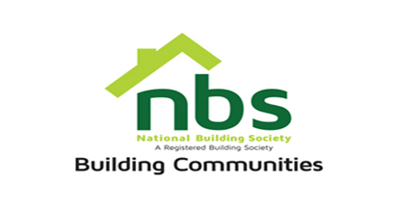
23 February 2024

REQUEST FOR QUOTATION
SUPPLY AND DELIVERY OF FURNITURE
PRICE SCHEDULE

Item | Description | Qty | Total Price
 | Expert grey desk 140 X 80 cm with modesty panel. 28mm thick melamine edged in 2mm thick ABS (with no side drawers) | 11
 | High end melamine L shaped grey executive desk with side drawers | 1
 | Ordinary Swivel chair low mesh black back, padded grey seat, nylon base. | 11
 | Vari visitor’s chair, low mesh black back, padded grey seat, nylon base. | 8
 | High end executive grey leather swivel chair | 1
 | 4 drawers steal cabinet for suspended file in grey metal H1320*W460*D620 | 9
 | Vat sum
 | TOTAL

Manner of Submission

Bids must be submitted through email on procurement@nbs.co.zw or in some other electronic forms are received before the end of the bidding period. Bids must be received at NBS Head Office on or before the closing date, before 10:00 hours on the closing date.

Offers not received by 10:00 hours on the closing date will be treated as late tenders, rejected and returned to tenderer. Last date of submission is 26/04/2024.

YOUR OFFER SHOULD CLEARLY INDICATE THE FOLLOWING:

- Bidders must respond to the specification on a line-by-line basis.
- A bid validity period of a minimum of 10 days from tender closing date must be firmly stated.
- Bidders must provide lead time/delivery period from date of receipt of official order.
- Bidders shall be required to quote in USD NOSTRO.
- NBS will not accept poor quality goods or service. Physical samples to be submitted together with the quotation and this is subject to approval.
- NBS reserves the right to accept or reject any Proposal(s), to cancel the bidding process and/or to reject all bids at any time prior to award, without incurring any liability to any of the Bidder(s).
- Bidders must attach proof of PRAZ registration, Zimra Registration (Tax Clearance Certificate).

