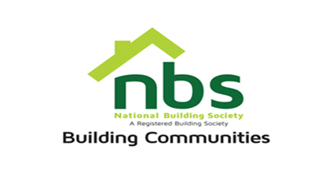
14 March 2024
REQUEST FOR QUOTATION

SUPPLY AND INSTALLATION OF AIR CONDITIONERS AT NBS CELESTIAL PARK

PRICE SCHEDULE
Item | Description | Qty | USD$  Unit Price | USD$  Total Price
 | 24000 BTUs Air Conditioning split units | 11
 | Vat sum
 | TOTAL

Manner of Submission
Bids must be submitted through email or in some other electronic forms are received before the end of the bidding period. Bids must be received at NBS Celestial Park Head Office on or before the closing date, No. 19280 Borrowdale Road, Block 1, Unit L, 2nd Floor, Harare before 10:00 hours on the closing date. Electronic submission to be sent to: tinashe.dani@nbs.co.zw Offers not received by 10:00 hours on the closing date will be treated as late tenders, rejected, and returned to tenderer.

Site Visit Date of Attendance at Celestial Park NBS: Friday 15th of March 2024 at 11.00hrs (must).

Closing Date for Submission: Monday 18th of March 2024 at 10.00hrs

YOUR OFFER SHOULD CLEARLY INDICATE THE FOLLOWING:

- Bidders must respond to the specification on a line-by-line basis.
- Bidders must attach the methodology and installation plan
- Bidders must confirm in writing that they will be able to provide a 12 month warranty for the installed system.(must)
- Bidders must provide lead time/delivery period from receipt of official order expressed in weeks (must).
- Bidders must attach proof of PRAZ registration, Current Tax Clearance Certificate & NSSA Certificate (must attach).
- Bidders must State Bid Validity for their Quotation (must attach).

N.B: All prices quoted in US$ should be payable in ZWL$ at the prevailing interbank rate. Costs to include all labour and consumable costs. No hidden costs and variations will be permitted

