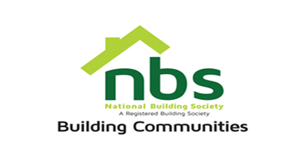
14 March 2024

REQUEST FOR QUOTATION

SUPPLY AND DELIVERY OF TENT HIRE, SPORTS GALA

PRICE SCHEDULE

Item | Description | Qty | Total Price ZWL$
 | 30 sitter tents + tables and chairs (EXECUTIVE SET UP)
 | Vat sum
 | TOTAL

Manner of Submission

Bids must be submitted through email on procurement@nbs.co.zw or in some other electronic forms are received before the end of the bidding period. Bids must be received at NBS Head Office on or before the closing date, before 12:00 hours on the closing date.

Offers not received by 12:00 hours on the closing date will be treated as late tenders, rejected, and returned to tenderer.

Last date of submission is 15/03/2023 at 12:00hours.

YOUR OFFER SHOULD CLEARLY INDICATE THE FOLLOWING:

- Bidders must respond to the specification on a line-by-line basis.
- A bid validity period of a minimum of 10 days from tender closing date must be firmly stated.
- Bidders must provide lead time/delivery period from date of receipt of official order.
- Bidders shall be required to quote in USD dollars only, but NBS Shall settle the payment in ZWL dollars at the prevailing RBZ Interbank rate.
- NBS will not accept poor quality goods or service.
- NBS reserves the right to accept or reject any Proposal(s), to cancel the bidding process and/or to reject all bids at any time prior to award, without incurring any liability to any of the Bidder(s).
- Delivery should be done upon issuance of an official purchase order; payment will be made after delivery. Prospective suppliers must confirm agreement to this condition.
- Bidders must attach proof of,
- A current NSSA clearance certificate showing that you contribute to NSSA and fully paid up
- current A proof of registration with Procurement Regulatory Authority of Zimbabwe (PRAZ registration)
- Valid Zimra Registration (Tax Clearance Certificate).

