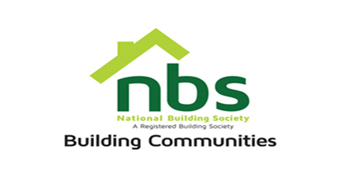
28 MARCH 2024
REQUEST FOR QUOTATION

SUPPLY AND DELIVERY OF INDUCTION GOLF TSHIRT

PRICE SCHEDULE

Item | Description | Qty | Total Price ZWL$
 | Light grey GOLF TSHIRT (see the sample attached) kindly note that we want exactly as on the picture | 50
 | Vat sum
 | TOTAL

Manner of Submission

Bids must be submitted through email on procurement@nbs.co.zw or in some other electronic forms are received before the end of the bidding period. Bids must be received at NBS Head Office on or before the closing date, before 10:00 hours on the closing date.

Offers not received by 10:00 hours on the closing date will be treated as late tenders, rejected, and returned to tenderer.

Last date of submission is 03/04/2024 at 10:00hours.
YOUR OFFER SHOULD CLEARLY INDICATE THE FOLLOWING:

1. Bidders must respond to the specification on a line-by-line basis.
2. A bid validity period of a minimum of 10 days from tender closing date must be firmly stated.
3. Bidders must provide a lead time/delivery period from date of receipt of official order.
4. Bidders shall be required to quote in USD dollars only, but NBS Shall settle the payment in ZWL dollars at the prevailing RBZ Interbank rate.
5. NBS will not accept poor quality goods or service.
6. NBS reserves the right to accept or reject any Proposal(s), to cancel the bidding process and/or to reject all bids at any time prior to award, without incurring any liability to any of the Bidder(s).
7. Delivery should be done upon issuance of an official purchase order; payment will be made after delivery. Prospective suppliers must confirm agreement to this condition.
8. Bidders must attach proof of,
• A current NSSA clearance certificate showing that you contribute to NSSA and fully paid up
• current A proof of registration with Procurement Regulatory Authority of Zimbabwe (PRAZ registration)
• Valid Zimra Registration (Tax Clearance Certificate).

