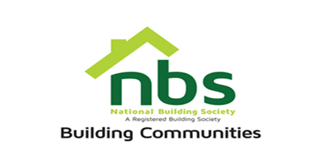
26 March 2024

REQUEST FOR QUOTATION

OFFICE FURNITURE FOR NBS BINDURA BRANCH

PRICE SCHEDULE

Item | Description | Qty | Unit Price (USD) | Total Price (USD)
 | Television set – rates board TV 43inch SMART TV | 1
2. | 30L Microwave | 1
 | Vat sum
 | TOTAL

N.B: Goods are to be delivered to Bindura Branch at NSSA Complex.

Manner of Submission

Bids must be submitted through email on procurement@nbs.co.zw or in some other electronic forms are received before the end of the bidding period. Bids must be received at NBS Head Office on or before the closing date, before 10:00 hours on the closing date.

Offers not received by 10:00 hours on the closing date will be treated as late tenders, rejected and returned to tenderer. Last date of submission is 03/04/2024.

YOUR OFFER SHOULD CLEARLY INDICATE THE FOLLOWING:

- Bidders must respond to the specification on a line-by-line basis.
- A bid validity period of a minimum of 10 days from tender closing date must be firmly stated.
- Bidders must provide lead time/delivery period from date of receipt of official order.
- Bidders shall be required to quote in USD dollars only, but NBS shall settle the payment in ZWL dollars at the prevailing RBZ Interbank rate.
- NBS will not accept poor quality goods or service.
- NBS reserves the right to accept or reject any Proposal(s), to cancel the bidding process and/or to reject all bids at any time prior to award, without incurring any liability to any of the Bidder(s).
- Bidders must attach proof of PRAZ registration, Zimra Registration (Tax Clearance Certificate), NSSA Registration. Bidders who fail to submit these documents will automatically be disqualified.

