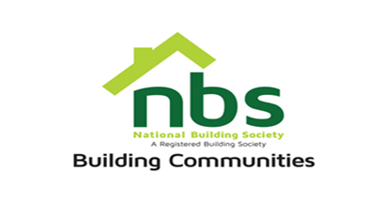
03 March 2024
REQUEST FOR QUOTATION

EXTERIOR BRANDING OF JM NKOMO BRANCH (BULAWAYO)

PRICE SCHEDULE
Item | Description | Qty | USD$  Unit Price | USD$  Total Price
 | EXTERIOR BRANDING:  • Window decals  • Signage  • Lightboxes | 1
 | Vat sum
 | TOTAL

Manner of Submission
Bids must be submitted through email or in some other electronic forms are received before the end of the bidding period. Bids must be received at NBS Celestial Park Head Office on or before the closing date, No. 19280 Borrowdale Road, Block 1, Unit L, 2nd Floor, Harare before 15:00 hours on the closing date. Electronic submission to be sent to: tinashe.dani@nbs.co.zw Offers not received by 15:00 hours on the closing date will be treated as late tenders, rejected, and returned to tenderer.

Site Visit Date of Attendance in Bulawayo NBS Branch: Friday 8th of March 2024 at 11.00hrs (must).

Closing Date for Submission: Tuesday 12th of March 2024 at 15.00hrs

YOUR OFFER SHOULD CLEARLY INDICATE THE FOLLOWING:

- Bidders must respond to the specification on a line-by-line basis.
- Bidders must attach the designs and assessments will be made on the quality of the designs.
- Bidders must provide lead time/delivery period from receipt of official order expressed in weeks (must).
- Bidders must attach proof of PRAZ registration, Current Tax Clearance Certificate & NSSA Certificate (must attach).
- Bidders must State Bid Validity for their Quotation (must attach).

N.B: All prices quoted in US$ should be payable in Nostrol. Costs to include all labour and consumable costs. No hidden costs and variations will be permitted

