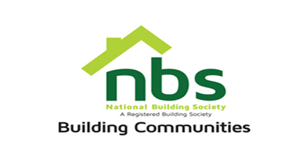
03 March 2024
REQUEST FOR QUOTATION

ENGAGEMENT OF A TOWN PLANNING CONSULTANT FOR THE PURPOSES OF REGULARISING DZIVARSEKWA HOUSE PLANS UPTO APPROVALS STAGE

PRICE SCHEDULE
Item | Description | Qty | USD$  Unit Price | USD$  Total Price
 | - Reproduction of working drawings/plans of the as-built existing 496 NBS DZ units.  - Printing, submission to/and securing of Council approvals for the working drawings/plans.  - Facilitating of building inspections for the existing 496 units in liaison with the Council Inspectorate. | 1
 | Vat sum
 | TOTAL

Manner of Submission
Bids must be submitted through email or in some other electronic forms are received before the end of the bidding period. Bids must be received at NBS Celestial Park Head Office on or before the closing date, No. 19280 Borrowdale Road, Block 1, Unit L, 2nd Floor, Harare before 15:00 hours on the closing date. Electronic submission to be sent to: tinashe.dani@nbs.co.zw Offers not received by 15:00 hours on the closing date will be treated as late tenders, rejected, and returned to tenderer.

Closing Date for Submission: Wednesday 13th of March 2024 at 15.00hrs

YOUR OFFER SHOULD CLEARLY INDICATE THE FOLLOWING:

- Bidders must respond to the specification on a line-by-line basis.
- Bidders must provide lead time/delivery period from receipt of official order expressed in weeks (must).
- Bidders must attach proof of PRAZ registration, Current Tax Clearance Certificate & NSSA Certificate (must attach).
- Bidders must State Bid Validity for their Quotation (must attach).

N.B: All prices quoted in US$ should be payable in Nostrol. Costs to include all labour and consumable costs. No hidden costs and variations will be permitted

