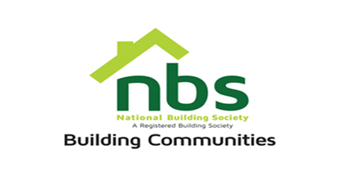
18 March 2024

REQUEST FOR QUOTATION

SUPPLY, INSTALLATION AND REPAIR OF AIRCON UNITS IN HARARE & CHINHOYI

PRICE SCHEDULE
Item | Description | Quantity | $  Unit Price | $  Total Price
 | Supply and Installation of 36,000BTU  - Location: Harare | 1
 | Supply and Installation of 12,000BTU  - Location: Chinhoyi | 1
 | Supply and Installation of 18,000BTU  - Location: Chinhoyi | 1
 | Supply and Repair of 12,000BTU Aircon Compressor  - Location: Chinhoyi | 1
 | Supply and Repair of 18,000BTU Aircon Compressor  - Location: Chinhoyi | 1
 | Supply and Repair of 18,000BTU Aircon Compressor  - Location: Chinhoyi | 1
 | Separation of Aircon Breakers 20Amp including Cabling and all related consumables.  - Location: Chinhoyi | 9
 | Vat sum
 | TOTAL

Manner of Submission

Bids must be submitted through email or in some other electronic forms are received before the end of the bidding period. Bids must be received at NBS Head Office on or before the closing date, 14th Floor SSC Building National Building Society Head Office before 10:00 hours on the closing date. Electronic submission to be sent to: procurement@nbs.co.zw Offers not received by 10:00 hours on the closing date will be treated as late tenders, rejected, and returned to tenderer.

Closing Date for Submission: 22 March 2024 at 10.00hrs

YOUR OFFER SHOULD CLEARLY INDICATE THE FOLLOWING:

- Bidders must respond to the specification on a line-by-line basis.
- A bid validity period of a minimum of 10 days from tender closing date must be firmly stated.
- Bidders’ lead time should be within 7 days delivery period from date of receipt of official order.
- Bidders shall be required to quote in USD dollars only, but NBS Shall settle the payment in ZWL dollars at the prevailing RBZ Interbank rate.
- NBS will not accept poor quality goods or service.
- NBS reserves the right to accept or reject any Proposal(s), to cancel the bidding process and/or to reject all bids at any time prior to award, without incurring any liability to any of the Bidder(s).
- Bidders must attach proof of PRAZ registration, Zimra Registration (Tax Clearance Certificate) & NSSA Registration.

