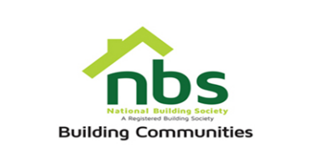
29 November 2023

REQUEST FOR QUOTATION

SUPPLY AND DELIVERY OF SPARE WHEEL AND WHEEL ALIGNMENT

Item | Description | Qty | $ Unit Price | $ Total Price
 | Spare Wheel for Honda Fit 175/70 R14 | 1
 | Wheel Alignment | 1
 | Vat sum
 | TOTAL

NB: Price to be quoted in US$ payable at interbank rates OR ZWL$.

Manner of Submission

Bids must be submitted through email or in some other electronic forms are received before the end of the bidding period. Bids must be received at NBS Head Office on or before the closing date, 14th Floor SSC Building National Building Society Head Office before 10:00 hours on the closing date. Electronic submission to be sent to: procurement@nbs.co.zw

Offers not received by 10:00 hours on the closing date will be treated as late tenders, rejected, and returned to tenderer.

Last date of submission is 08/12/2023 at 10:00hours

YOUR OFFER SHOULD CLEARLY INDICATE THE FOLLOWING:
- Bidders must respond to the specification on a line-by-line basis.
- Bidders must provide lead time/delivery period from receipt of official order expressed in days (must).
- Bidders must attach proof of PRAZ & NSSA registration (must).
- Bidder must attach proof of Tax Clearance Certificate (must).
- NBS will not accept poor quality goods or service.
- NBS reserves the right to accept or reject any Proposal(s), to cancel the bidding process and/or to reject all bids at any time prior to award, without incurring any liability to any of the Bidder(s).
- Delivery should be done upon issuance of an official purchase order; payment will be made after delivery. Prospective suppliers must confirm agreement to this condition.

