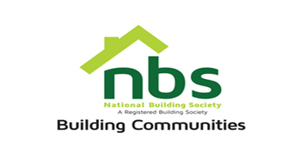
August 1, 2022

REQUEST FOR QUOTATION

Request for quotation for branded pens

PRICE SCHEDULE

Item | Description | Number of pens | Unit Price | Total Price
 | We require a quotation for branded parker pens | 1000
 | We require a quotation for branded ever sharp pens | 1000
 | Vat sum
 | TOTAL

Manner of Submission

Bids must be submitted through email or in some other electronic form are received before the end of the bidding period which is Wednesday 3 August 2022. Bids must be received at NBS Head Office on or before the closing date, before 10:00 hours on the closing date.

Offers not received by 10:00 hours on the closing date will be treated as late tenders, rejected and returned to tenderer.

YOUR OFFER SHOULD CLEARLY INDICATE THE FOLLOWING:

- Bidders must respond to the specification on a line by line basis.
- A bid validity period of a minimum of 10 days from tender closing date must be firmly stated.
- Bidders must provide lead time/delivery period from receipt of official order expressed in weeks.
- Bidders must attach proof of PRAZ registration, Zimra Registration (Tax Clearance Certificate).

