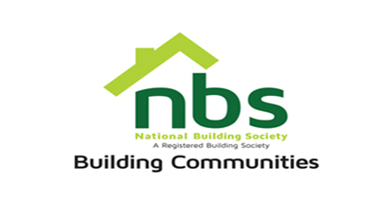
1 August 2022

INVITATION TO SITE VISIT

SITE VISIT INVITATION FOR INSTALLATION OF A FIREWALL

Item | Description | Date | Time | Place
 | National Building Society is inviting you for a site visit regarding the installation of a firewall in the ICT data base | 5, August 2022 | 10:30 AM | NBS Head Office, SSC Building 14th floor corner Sam Nujoma and Julius Nyerere

NB: Only suppliers who attend the site visit will be considered.

